**EXTRA PRACTICAL: 01**

**Aim: Belkasoft Acquisition Tool**

Step 1: Open Acquisition Tool

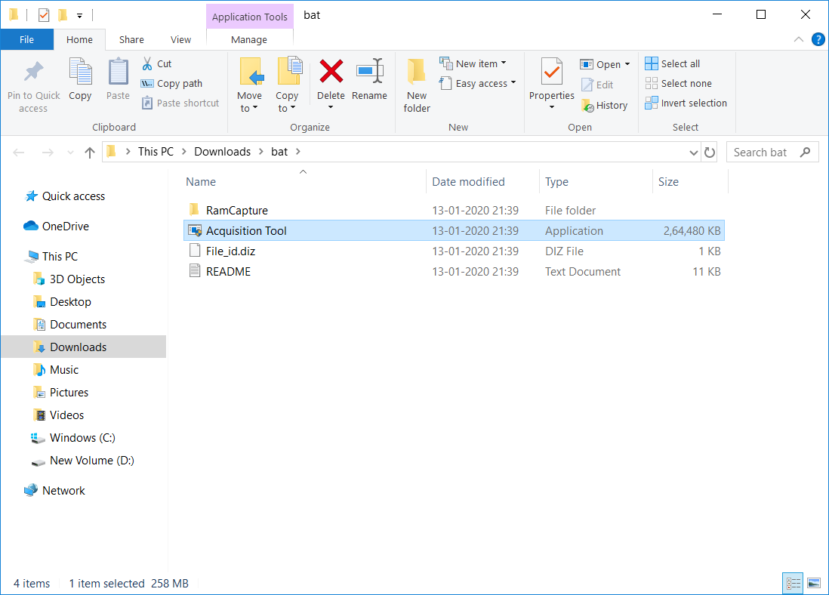

Step 2: Select the type of source you want to acquire (drive, mobile, cloud).

Step 3: Select the mobile type for acquisition.

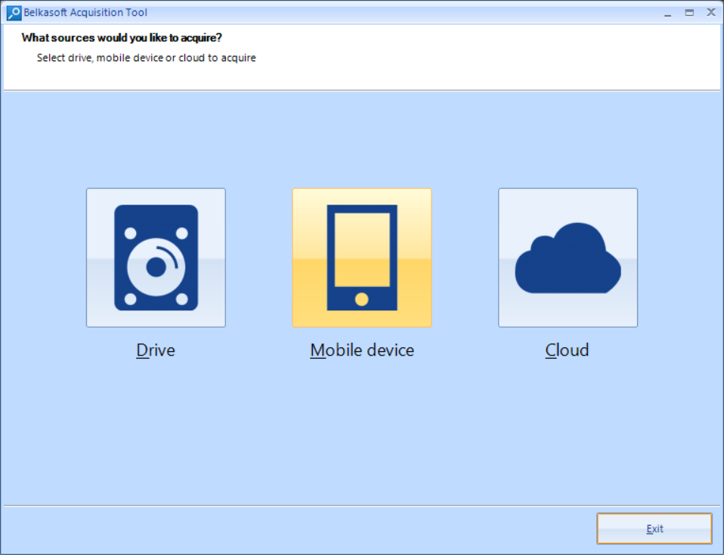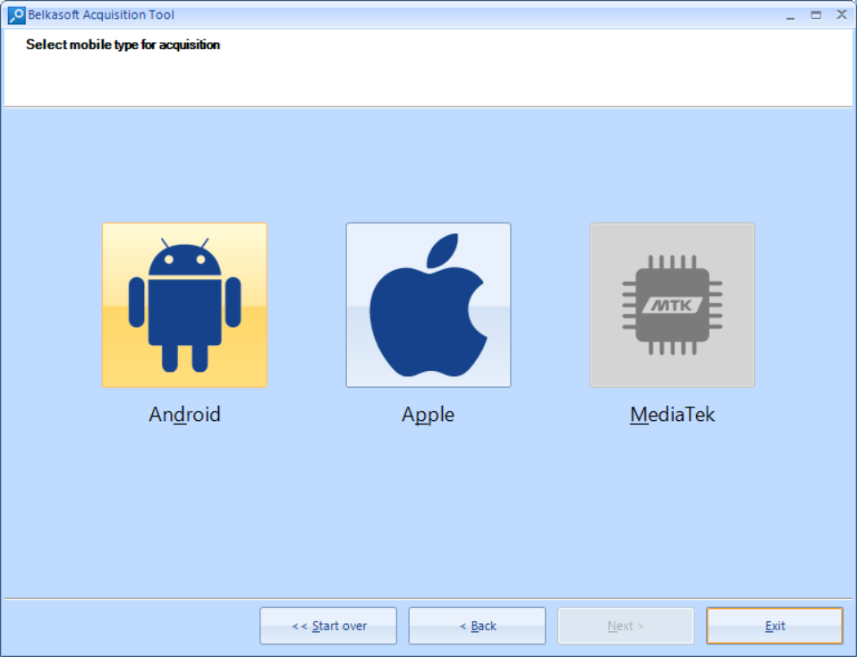

Step4: Select the acquisition method and set the target path.

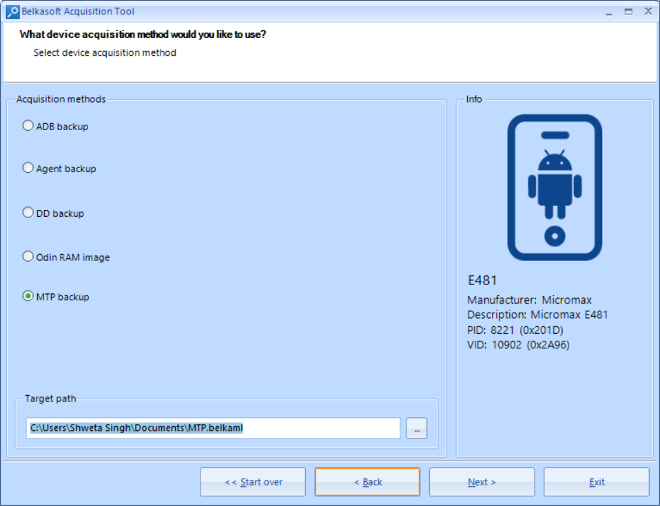

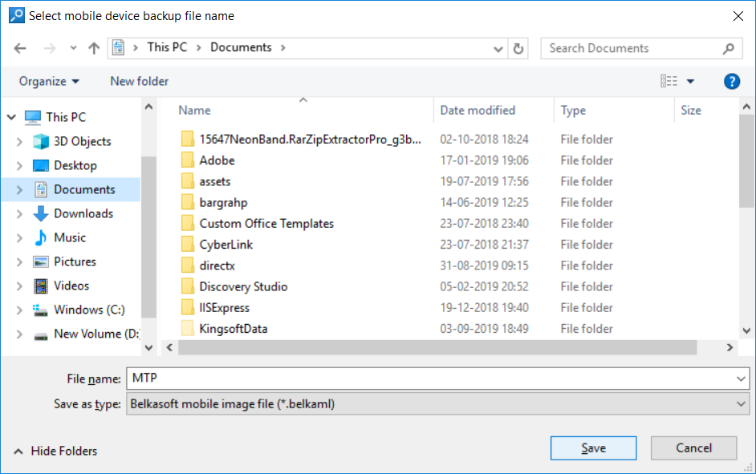 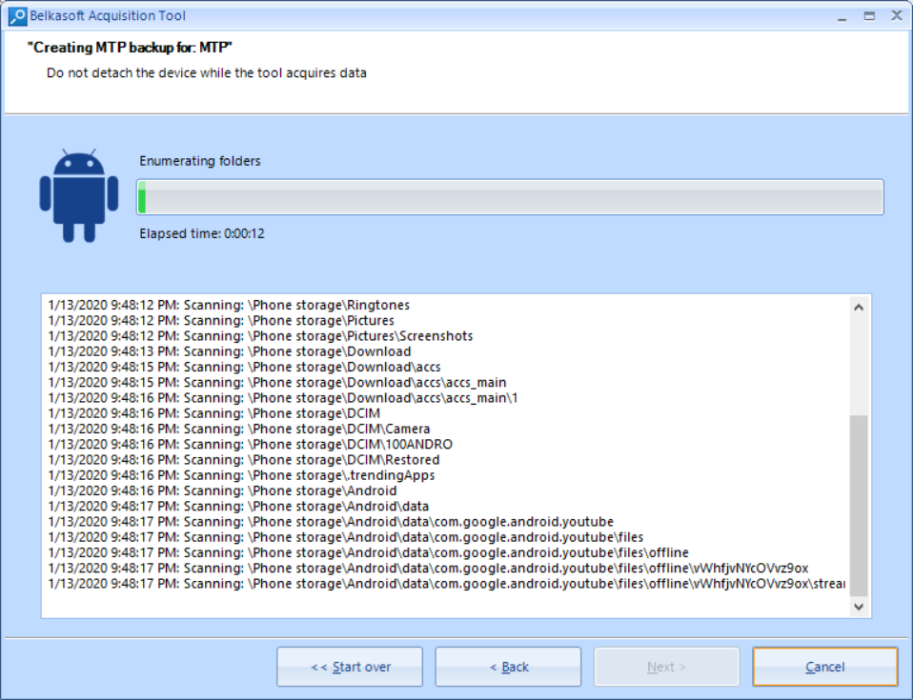

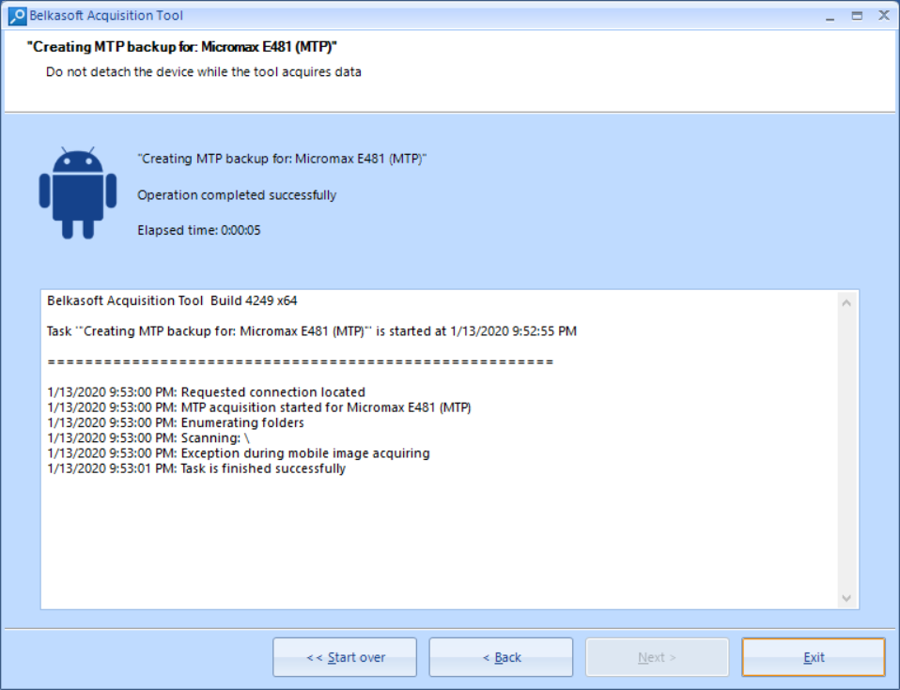

**EXTRA PRACTICAL: 02**

**AIM: GSUITE FOR HEADER ANALYSIS**

Step1: Open the official website if gsuite for header analysis.

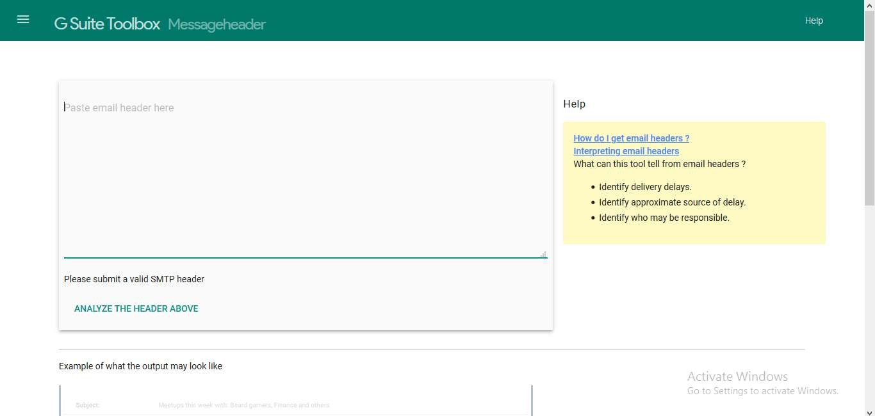

Step2: Copy an email header and paste it in the block and click on analyse.

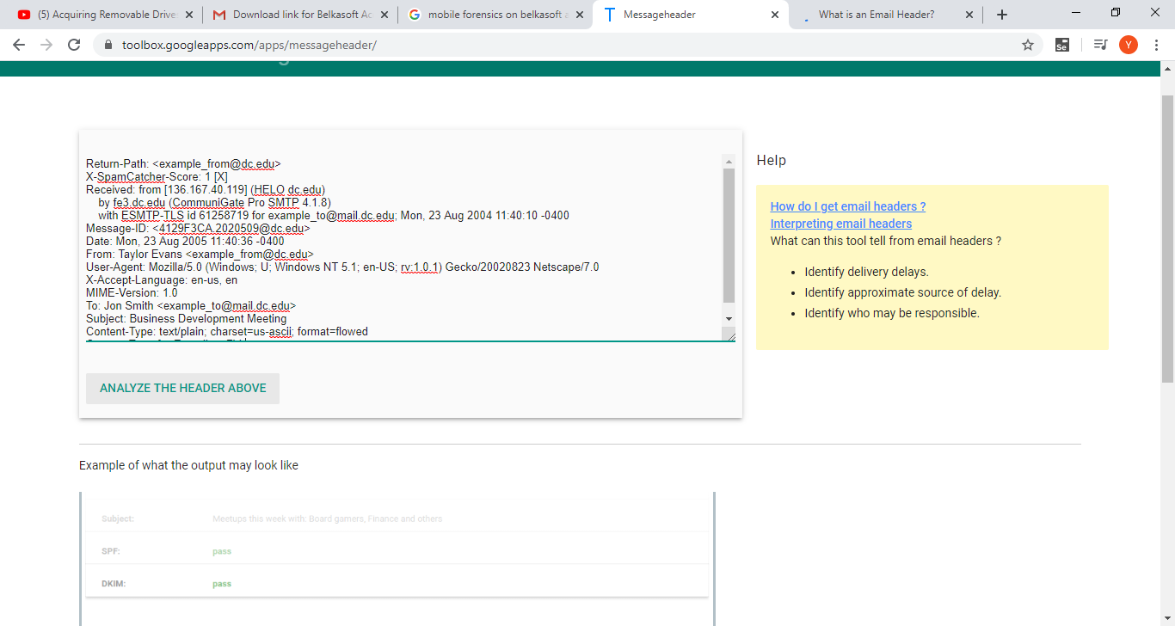

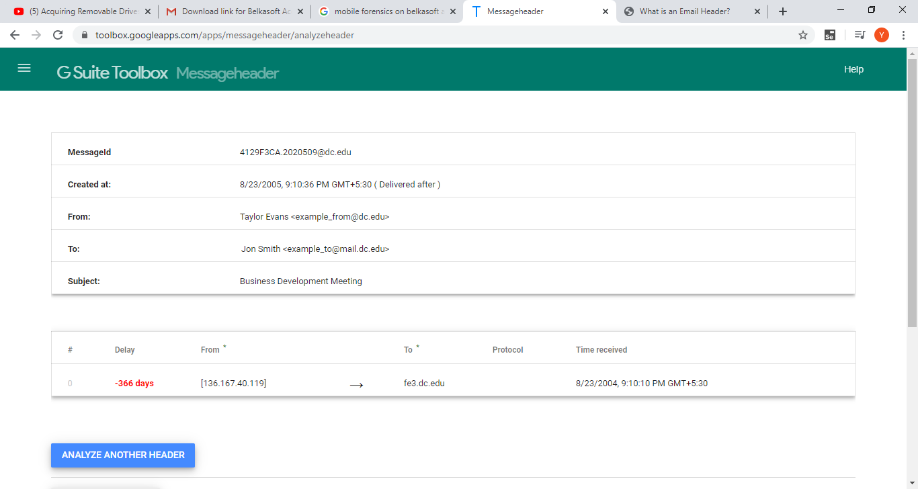

**EXTRA PRACTICAL: 03**

**AIM: CHROME CACHE VIEWER**

Step1: Download chrome cache viewer.

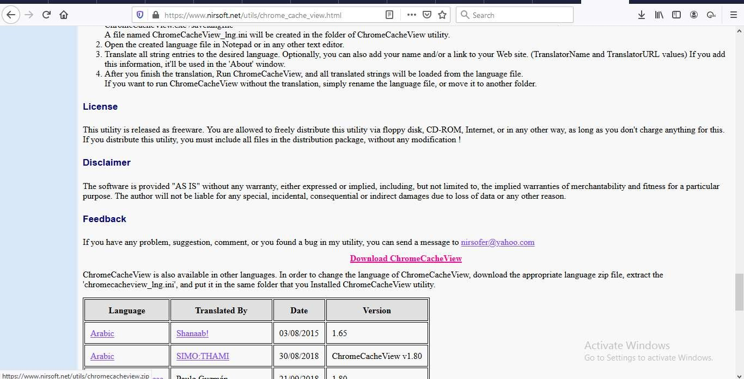

Step2: After the download is completed. Extract the rar file.

Step3: Open the extracted file.

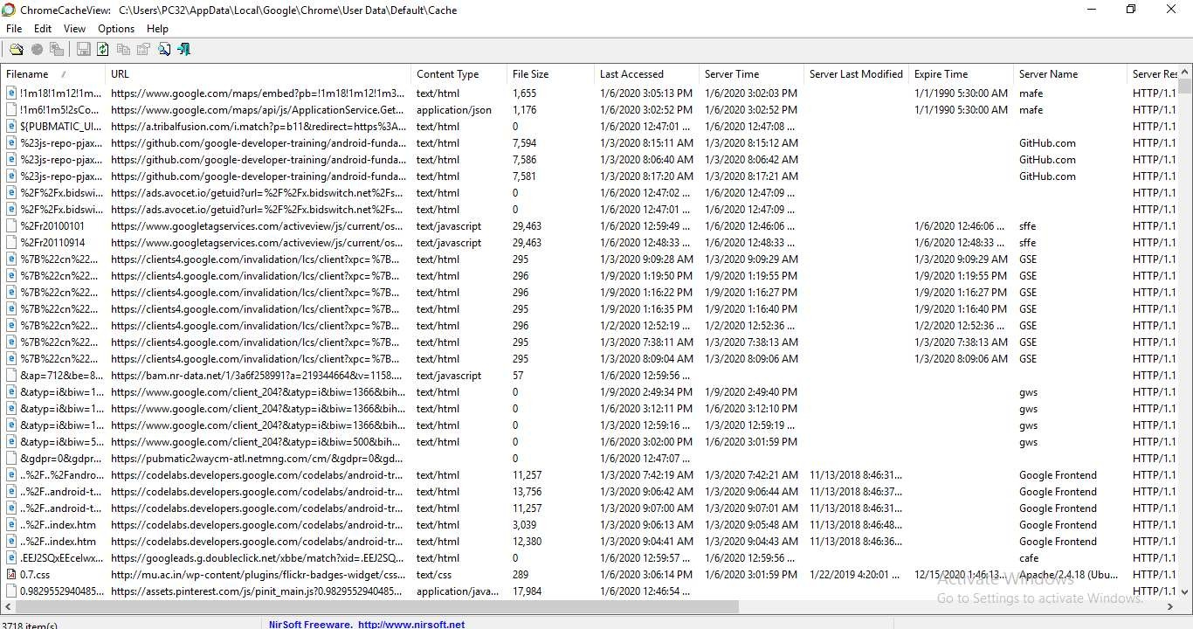

**EXTRA PRACTICAL: 04**

**AIM: MOZILLA COOKIE MANAGER**

Step1: Type in Mozilla cookie manager in the search engine and click on add to firefox.

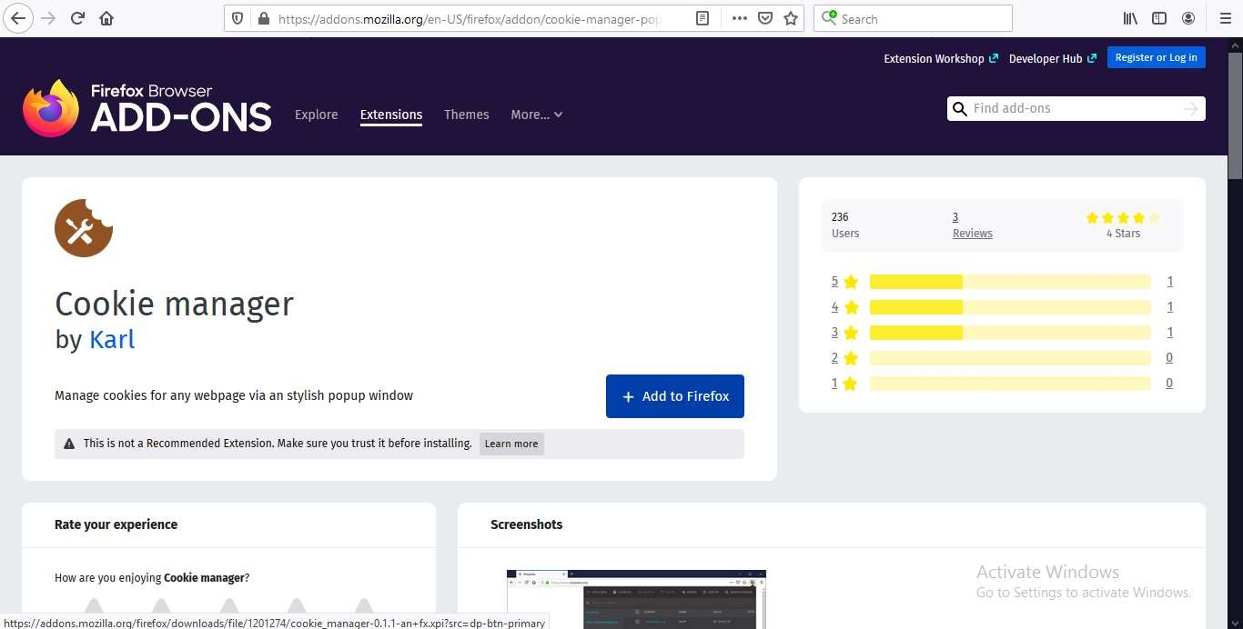

Step2: Click add on all the pop-ups.

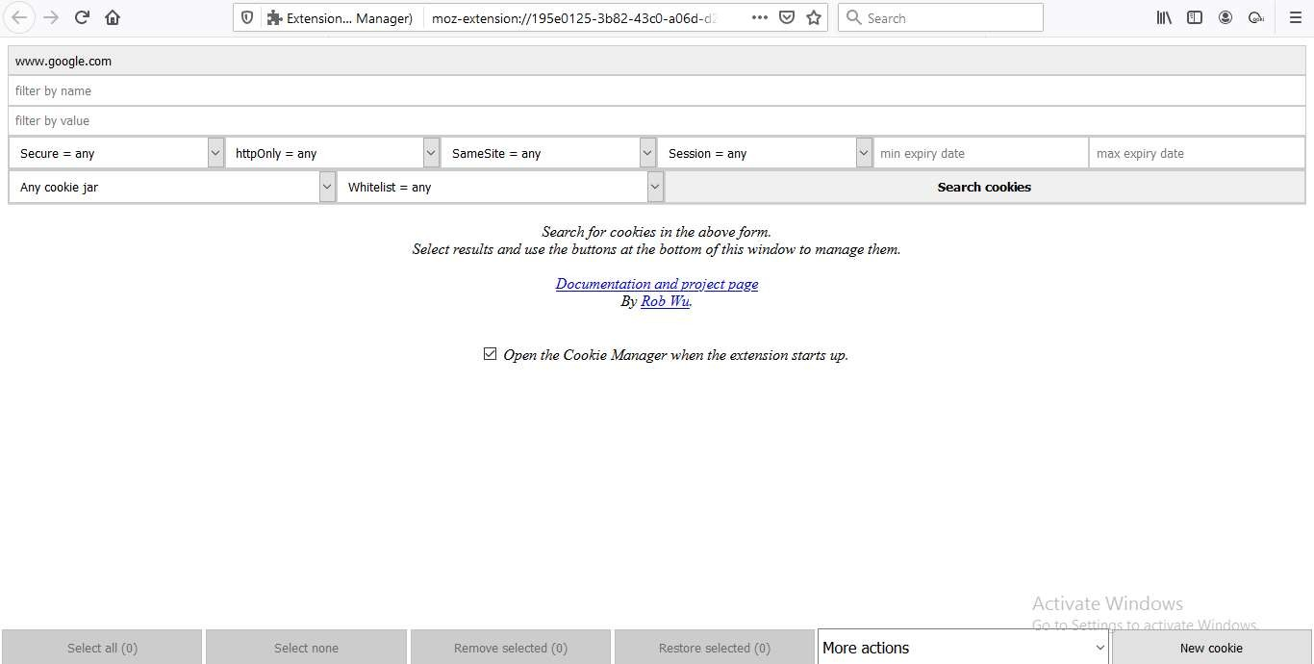

Step3: Now click on search cookies.

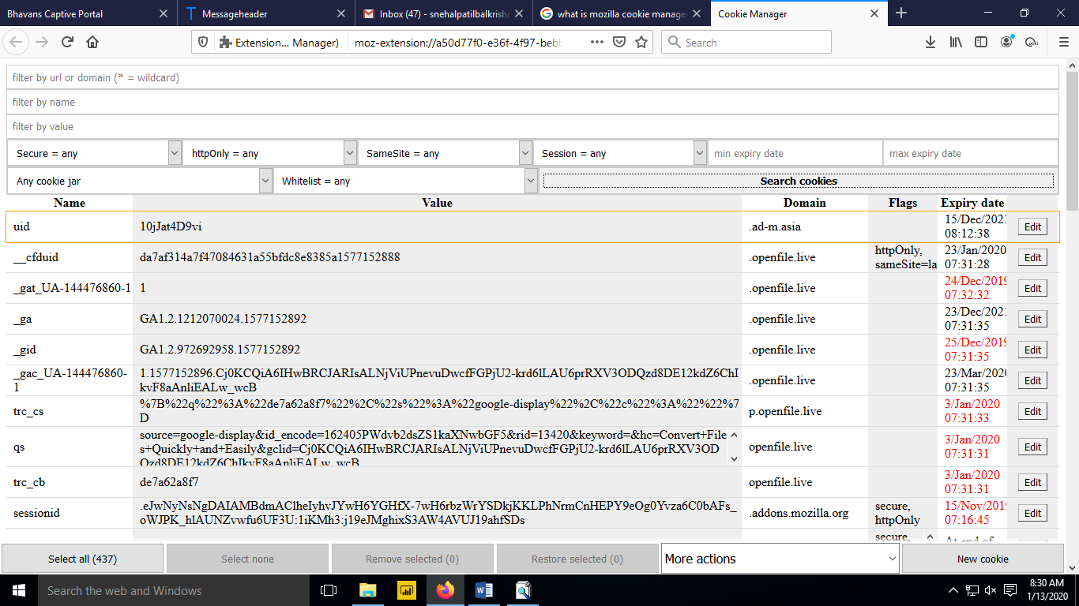

**EXTRA PRACTICAL: 05**

**AIM: MYLASTSEARCH**

Step1: Download mylastsearch.

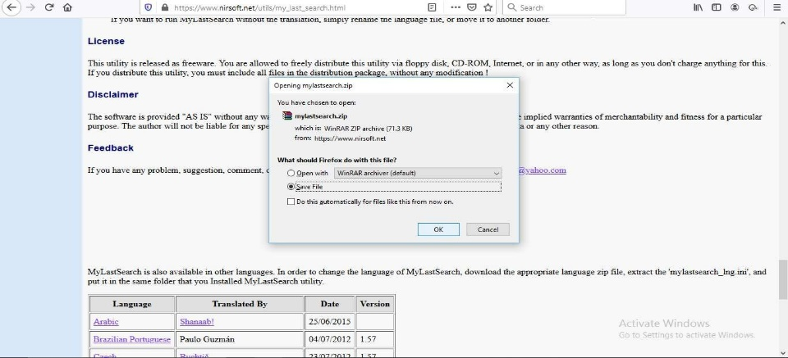

Step2: After the download is completed. Extract the rar file.

Step3: Open the extracted file.

Step4: On the Incognitive mode and search for something

